<https://www.youtube.com/watch?v=1_Zs0gQq1Yc&list=PL6flErFppaj35spJjPy41-lruDjw2kRV->

1. **HOW TO INSTALL JENKINS ON WINDOWS 10**
2. **QUICK TOUR OF JENKINS**For the above videos, refer Ragav Pal pdf.
3. **HOW TO CONFIGURE JENKINS ON WINDOWS**Manage Jenkins -> Configure System

Home directory – Default place where test is run

System message – The message displays when you open Jenkins

# executors – No of agents that you can have. At the left if you see there are 2 agents at the max which are idle.

Quiet period – The time for which Jenkins waits after you trigger a build

Get the ip address of the machine and update it here instead of local host. Now other machines from **SAME NETWORK CAN ACCESS JENKINS**

**Updated url :** [**http://9.199.96.199:8080/**](http://9.199.96.199:8080/)

Mange Jenkins -> Global System Configuration

Add Java, in JDK installations. For git you can leave it as it is. It will detect the git.exe path

Likewise, install Maven and add it in MAVEN_HOME

1. **HOW TO CREATE JENKINS JOB**

Create a freestyle project

1. **CONFIGURE EMAIL NOTIFICATIONS IN JENKINS**

There are two types. One is Extended email and another is Email.

Here, SMTP server and SMTP Port for gmail are below. If you need for your office mail, get it from IT support team.

Select below check box for test email and click on Test configuration

Now issue is bcos gmail has security issues. For that make sure to Add the multi factor authentication for the Gmail account,   
  
Navigate to this site and follow the below steps <https://myaccount.google.com/apppasswords?pli=1&rapt=AEjHL4OLJ9rnASPYFwoKYa5vhz6MOJQpbifMPgBZ-M1__QaBcLl3-80aQF7JE8tDH-f31HnqDGS97WOaz6OkFZMB1-mY8GX1gg>  
  
Now give that pw in Jenkins and test configuration.

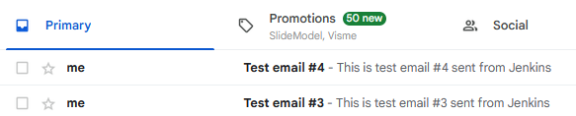

For extended email notification

Default Recipients – You can add whichever recipients email needs to be sent.

The below is the default subject and content of the mail.

The below are default triggers where you can send emails based on status of jobs. WE are setting ALWAYS

Now the general configuration is done. Now when you go to the job, you have these parameters getting populated.  
  
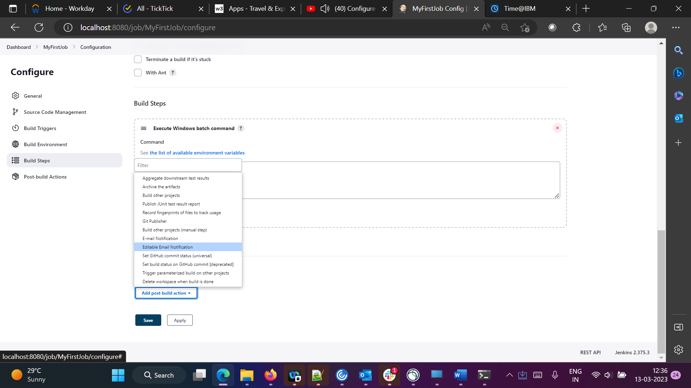

Now $DEFAULT_ is something that is fetched from Configure system option which was done previously. We are adding two more emails since we have not added any emails in the Configuration.

Click on Add Triggers with below options.

If you need multiple triggers you can do so using Add Trigger. Click on apply save and build your project.

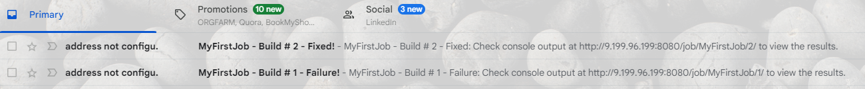

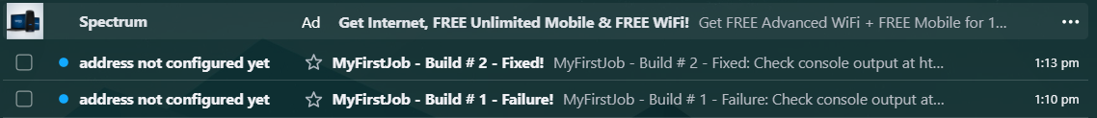

Understand the difference between Send Recipients and email configuration. Email configuration is the sender of the mail and Send Receipients are the receivers.

1. **HOW TO INSTALL PLUGIN IN JENKINS**

Not much important

1. **BUILD MAVEN PROJECT USING JENKINS**

Create a new Job called SeleniumTest

Method 1

If you go to this path and give this command, mvn recognizes tests with test attribute and runs

<https://maven.apache.org/surefire/maven-surefire-plugin/examples/inclusion-exclusion.html>

We have already configured Maven in global tool configuration so only this is fine.

Now build succeeds

Create a new job called SeleniumTestNew

Method 2

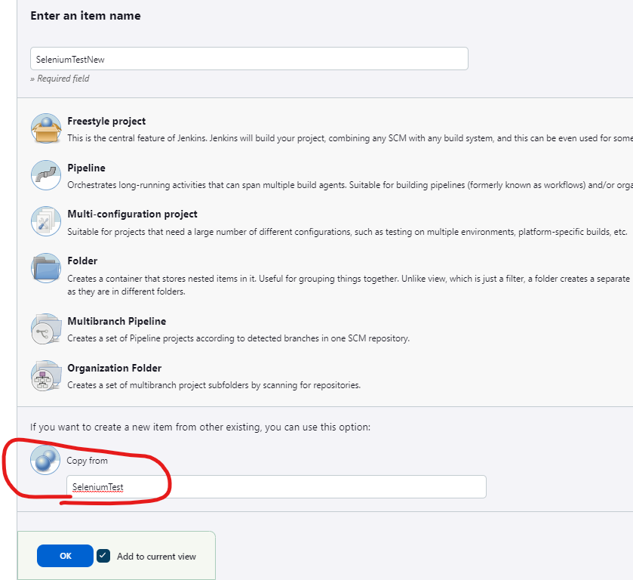

Create a new job called SeleniumTestNew

Method 3

Go to Manage Jenkins -> Plugin Manager -> Install “Maven Integration” Plugin

The plugin displays the Maven Project

1. **HOW TO CONFIGURE JENKINS WITH GITHUB  
     
   Graphical user interface, text, application, email

   Description automatically generated**

Enter the repository URL, Credentials can be added using add options. Here it is already populated since we have already added in Manage credentials.  
  
In the POM path, give the folder and the pom.xml path. So Jenkins takes that path and runs the below commands for that pom.xml file

Now remote repository gets cloned and the pom.xml at the specified location also gets run.

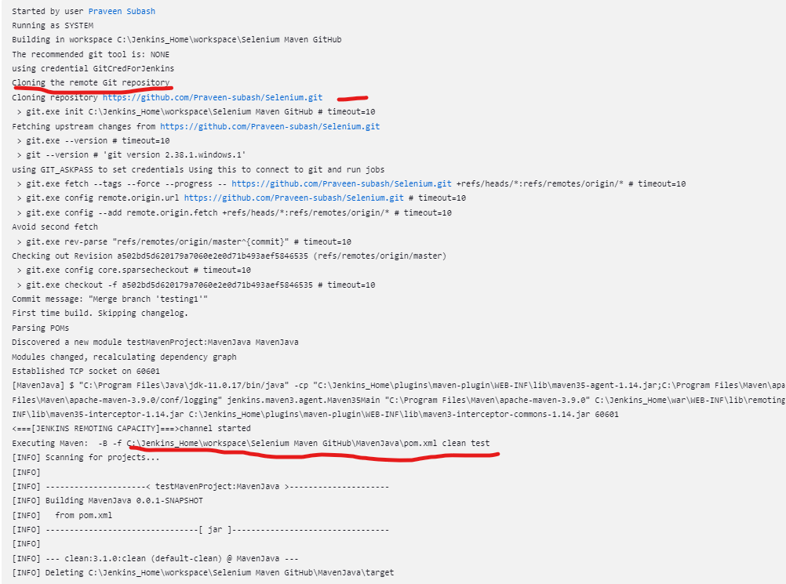

If you just specify pom.xml without giving the path, we get this error

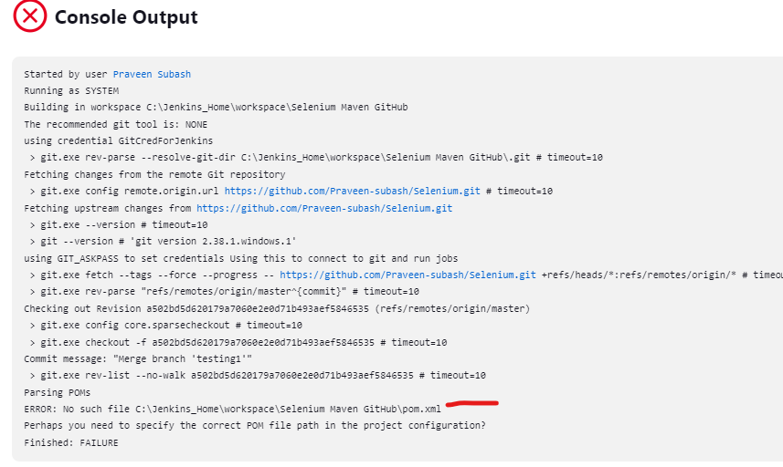

Before this Parameter topic have look on Parameters and how its passed in TestNG  
Here, we are passing a parameter through Maven not from testing.xml.

So, we are passing the key and name of the variable as shown below.

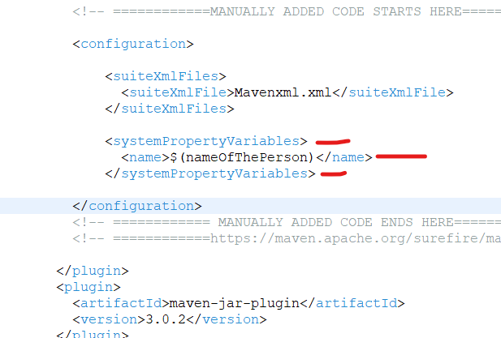

In the code, pass the key name as below

Now when you send the maven command mvn test -Dname=Praveen,  
Praveen gets printed.

Similarly, if you don’t want to use Parameters, you can use System.getProperty(“name”)

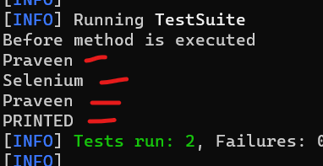

[command line - How to pass java code a parameter from maven for testing - Stack Overflow](https://stackoverflow.com/questions/13245411/how-to-pass-java-code-a-parameter-from-maven-for-testing)

This code has been pushed to git so we can run it now.

Now it is not a good practice to hard code any parameter in Maven commands. Someone who is using this job will not be able to do it everytime. So, we can parameterize this.

Now when you try to build, you see this option. Give any name and build.

Now code gets executed.

1. **HOW TO CREATE JENKINS JOB WITH PARAMETER**

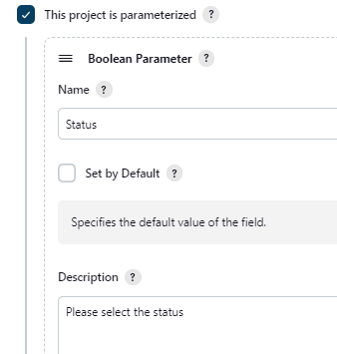

Credential Manager – Used to store credentials.

File Parameter – Used to attach files.

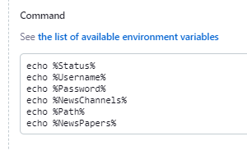

1. **AUTOMATICALLY TRIGGER JENKINS JOBS USING GIT WEBHOOKS**

Check this box and create webhook in Git. If you check Poll SCM we need to give polling time. This option kicks the job as soon as a push is done.

WE ARE NOT DOING THIS SINCE NGROCK IS NOT SAFE. POSTED SCREENSHOTS ALONE

Go to the git repository setting and click on webhook - Add webhook

Download and install ngrock in your system and check if its installed properly

Now execute the below command where the ngrok.exe is available.



Now, this link and local host 8080 are same. This will be valid for 2 hrs. Now paste think and suffix it with github-webhook. Select when you want to trigger this webhook and Add webhook

Now check in Jenkins if job is triggered after making a change in git .

1. **HOW TO RUN JENKINS JOBS PERIODICALLY**

Sample of a cron pattern

[Crontab.guru - The cron schedule expression editor](https://crontab.guru/) – Refer this site for cron pattern generator

In Jenkins instead of MON,TUE we give 0-7 where 0 and 7 are sundays

Poll SCM : You can give polling time whenever a git push is done. So this will scan the repo everytime.

Ex : If we give ***** it checks every 1 minute. If you give */2 ***** it will poll every 2 min and runs whenever a push is done.

1. **HOW TO CREATE UPSTREAM AND DOWNSTREAM JOBS IN JENKINS**

Create 3 jobs Build, Test, Deploy with echo commands to print job name

Under Build Job,

Go to Testing Job and add the below option to chain the job.

Likewise do the same for Deploy job and give the pre requisite job as Test

NOTE : There are two options for this. One is Post Build Action -> Build Other Projects and other is Build Triggers -> Build after other projects are built.

Post Build Action -> Build Other Projects is used when you want a downstream job to run after the completion of current job.

Build Triggers -> Build after other projects are built is used when you want to run the current job after upstream job is run.

Now when you go to each job, we can see the pre req and post requisite jobs.

Now when you build the Build Job, we can see the console as below

So Testing and Deploy job gets run eventually.

***How to pass parameters from one job to another ?***

Adding a a Default parameter in Test job as below

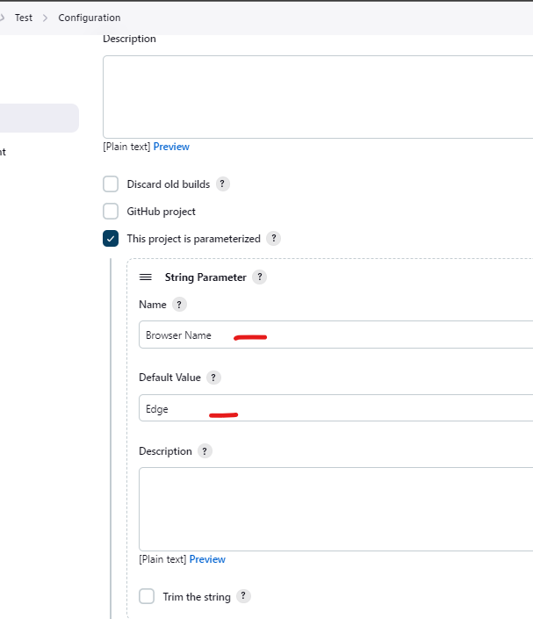

Adding it in windows command

Now install the plugin called “Parameterized Trigger”

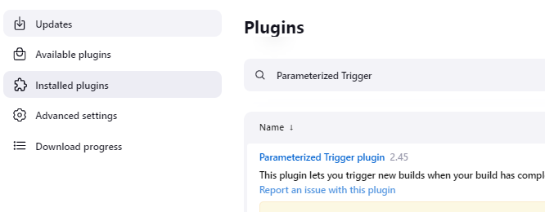

Now got to Build Job. Add a post build action called Trigger parameterized build on other projects.

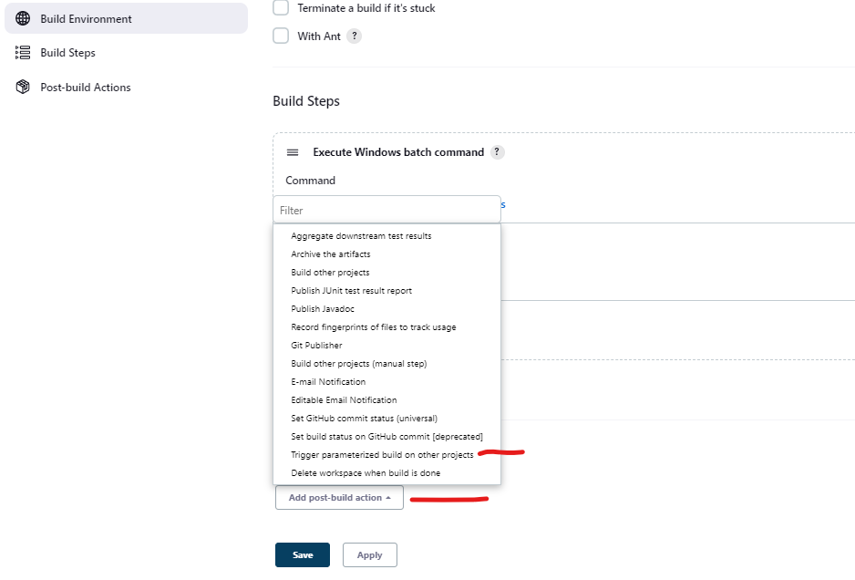

Delete the below option since we are adding a alternative

We have Browser_Name as Edge as a default parameter in Test job. So we are sending Chrome as a predefined parameter from Build Job.

The default value was Edge as given in the test job. But since we are sending parameters from Build Job, Chrome is printed

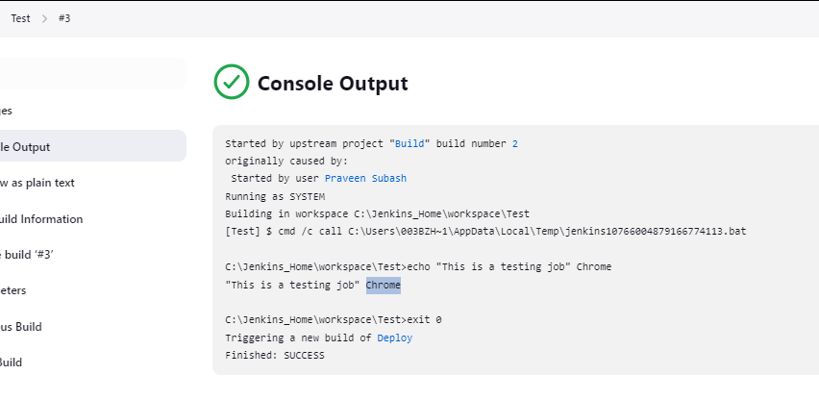

Now to view the chained jobs as a pipeline, install this plugin. This is not a pipeline creation this is just a view

Create a view of these chained jobs as below by clicking on + symbol in home screen

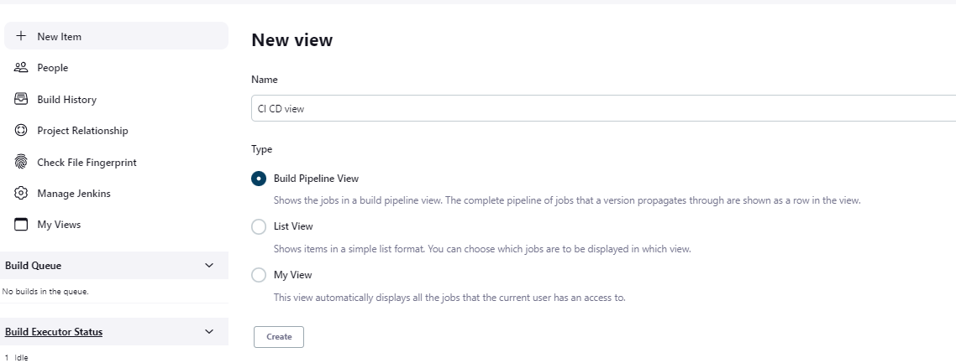

Now we can see the view like this

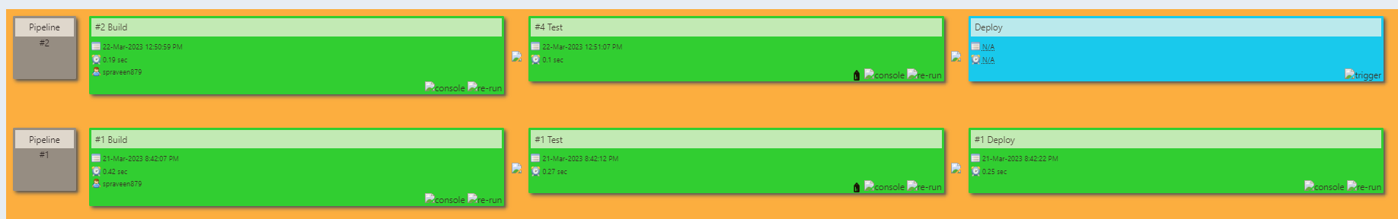

1. **WHAT IS JENKINS PIPELINE ?**

JenkinsFile is writing of Jenkins Pipeline using scripting.

Create a pipeline as below.

Click on apply save.

You can check the samples as shown below.

Agent – Give the agent name. We don’t have any master slave concept so we are having any.

Update the pipeline script as below

Click on Build Now

To generate syntax, go to Pipeline Syntax and get help

Select the category for which you need help and enter the parameters. It generates the groovy script

Now we are adding this to the existing code. Instead of post build actions we are using post

Click on build now

Note : Make sure that email id is configured before adding this step.